Effect of AC poling on electrical properties of PbTiO₃ single crystal (Times New Roman 12 pt)
John Yamashita¹, Cong Luo², Yiqin Sun¹, ¹Institution, City, Country, ²Institution, City, Country (Hereafter Times New Roman 11 pt)

Abstract: (within 100 words)
We demonstrate an alternating current poling (ACP) process to engineer the domain structures of originally rhombohedral (Pb_{0.95}La_{0.05})[(Mg_{1/3}Nb_{2/3})_{0.68}-Ti_{0.32}]O₃ (PLMN-PT) single crystals (SCs) to simultaneously generate near-perfect transparency, an ultrahigh piezoelectric coefficient d₃₃ (2,480 pC/N), high dielectric permittivity (6800), and an excellent electromechanical coupling factor k₃₃ (about 97 per cent) and a large electro-optical coefficient γ₃₃ (approximately 300 pm/v), which is far beyond the performance of the commonly used transparent ferroelectric crystal LiNbO₃. The ACP condition were 0.1 Hz, 24 cycles. The AC poling is a smart, economical, and high-cost performance process to enhance electrical and optical properties for PLMN-PT SCs. (This is an example, 99 words)

Background, Motivation and Objective
Your text explaining what has been done previously and why this work is of importance.

Statement of Contribution/Methods
Description of equipment, methods used.

Results/Discussion
Presentation of the results obtained and discussion of the results.

Text, Figures, and Table may be completed with a clearly readable image. (Example image)

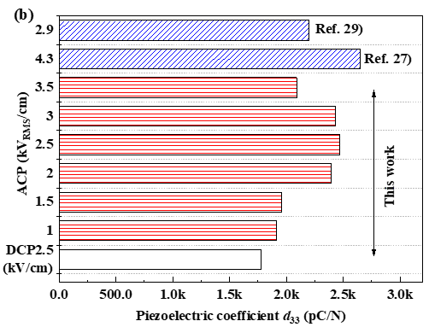
Table 1. Electrical properties of various relaxor-PT SCs after ACP.
Sample | ${ε_{33}^{T}/ε}_{0}$ at 25ºC | tan δ (%) | d₃₃ (pC/N)
0.75PMN-0.25PT  0.70PMN-0.30PT  0.70PMN-0.30PT  0.70PMN-0.30PT  0.7PMN-0.3PT  PMN-PIN-PT  PLMN-0.32PT | 6397  8500  6690  6250  7570  4246  6800 | -  -  0.32  -  0.25  0.8  1.1 | 1730  1980  1820  1860  1930  1413  2490

Fig. 1. d₃₃ vs. ACP voltages for PLMN-PT SC.

Abstract without image: Text must be less than 2500 characters excluding spaces, title, author names, and affiliations. Abstract with an image: Text with an image must be less than 2000 characters excluding spaces, title, author names, and affiliations.
Abstract should be within 1 page using A4 size with 25 mm top & bottom, and 14 mm left & right margins.

